**Full forms**

* HTMl (Hypertext markup language)

**Basic of html**

<Html> - root

<Head> - optional

1. 1.Html

<html>

<head>

<title> Demo </title>

</head>

<body>

Hello world

</body>

</html>

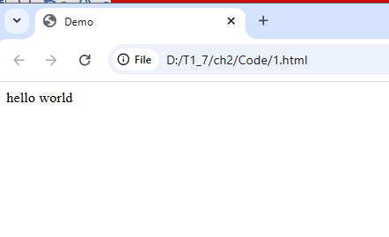

Data formatting tag

1. <b>
2. <i>
3. <u>
4. <br>
5. <hr>
6. <center>
7. <em>
8. <strong>
9. <sup>
10. <del>
11. <ins> → underline
12. <mark>
13. <small>
14. <sub>
15. <big>
16. <abbr>

2) 2.html

<html>

<body>

this is normal txt

<b>

This is bold text

</b>

</body>

</html>

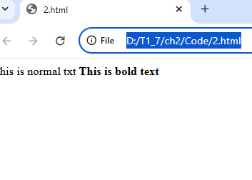

**3.html**

<html>

    <body>

        this is normal txt

        <i>

            this is italic txt

        </i>

    </body>

</html>

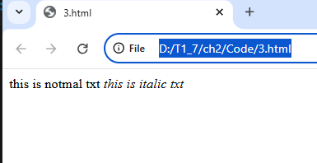

4.html

<html>

    <body>

        this is normal txt

        <u>

            under line txt

        </u>

    </body>

</html>

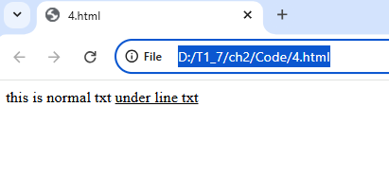

5.html(break line)

<html>

    <body>

        hello <br> student <br> ljku

    </body>

</html>

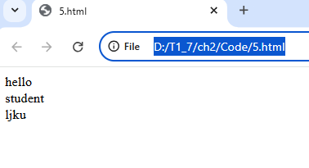

6.html

<html>

    <body>

        abc <hr> def <hr> xyz

    </body>

</html>

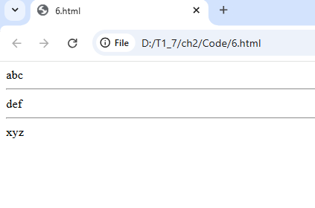

7.html

<html>

    <body>

        <center>

            yooo

        </center>

    </body>

</html>

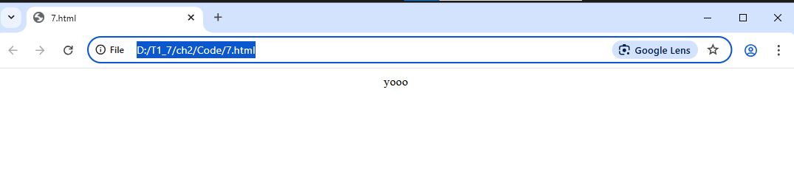

8.html

<html>

    <body>

        <i>

            italic

        </i>

        <em>

            em test

        </em>

    </body>

</html>

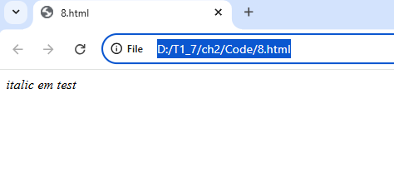

9.html

<html>

    <body>

        normal txt

        <strong>

            strong

        </strong>

        <b>

            bold txt

        </b>

    </body>

</html>

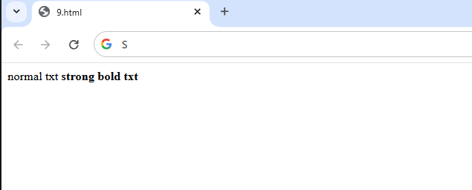

10.html

<html>

    <body>

        normal txt

        <sup>

            sup txt

        </sup>

    </body>

</html>

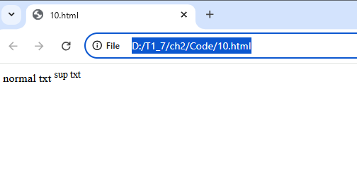

11.html

<html>

    <body>

        h <sub>2</sub> o

    </body>

</html>

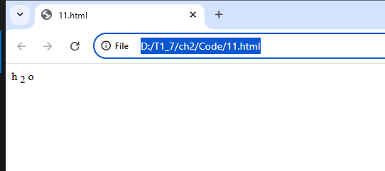

12.html

<html><body>

    normal <del> del txt</del> normal

</body></html>

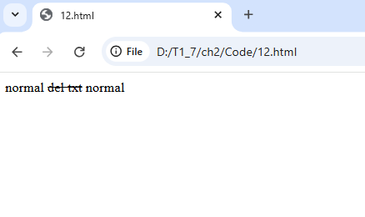

13.html

<html>

    <body>

        normal

        <ins>

            ins

        </ins>

        <u>

            under line

        </u>

    </body>

</html>

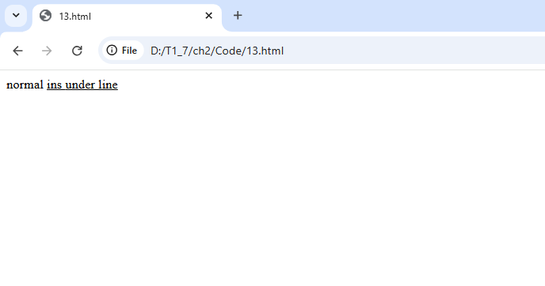

14.html

<html>

    <body>

        normal txt

        <mark>

            mark txt

        </mark>

    </body>

</html>

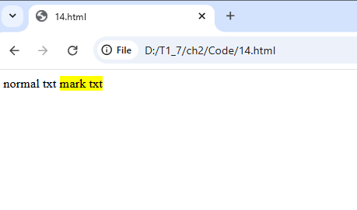

15.html

<html>

    <body>

        normal txt

        <small>samll txt</small>

    </body>

</html>

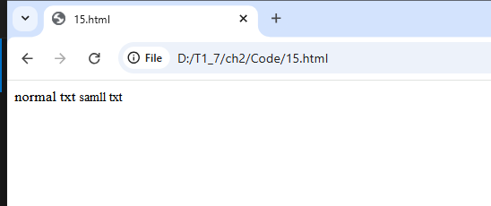

16.html

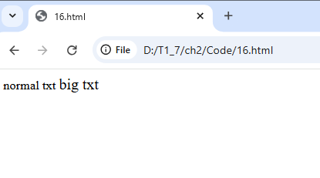

<html>

    <body>

        normal txt

        <big>

            big txt

        </big>

    </body>

</html>

**Heading txt**

1. <h1> - </h1> ………<hn> - </hn>

<html>

    <body>

        <h1> h1 </h1>

        <h2> h2 </h2>

        <h3> h3 </h3>

        <h4> h4 </h4>

        <h5> h5 </h5>

        <h6> h6 </h6>

    </body>

</html>

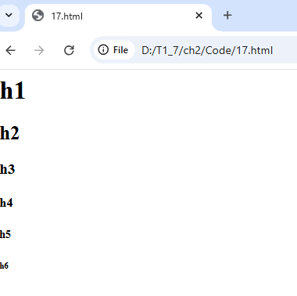

**Paragraph tags**

<p> paragraph tag

18.html

<html>

    <body>

        <p>

            afghfgewdferr hfrb fgbh trgbh gtrhbrgtbv b gb frbgtgrtbh trhrtgbhrtn

            ybn tghbn fg tbn

            fvvv defrvgr fvgjhkjhkc jujhfjnxc edjkjkecffrcer

            afghfgewdferr hfrb fgbh trgbh gtrhbrgtbv b gb frbgtgrtbh trhrtgbhrtn

            ybn tghbn fg tbn

            fvvv defrvgr fvgjhkjhkc jujhfjnxc edjkjkecffrcer afghfgewdferr hfrb

            fgbh trgbh gtrhbrgtbv b gb frbgtgrtbh trhrtgbhrtn

            ybn tghbn fg tbn

            fvvv defrvgr fvgjhkjhkc jujhfjnxc edjkjkecffrcer

        </p>

    </body>

</html>

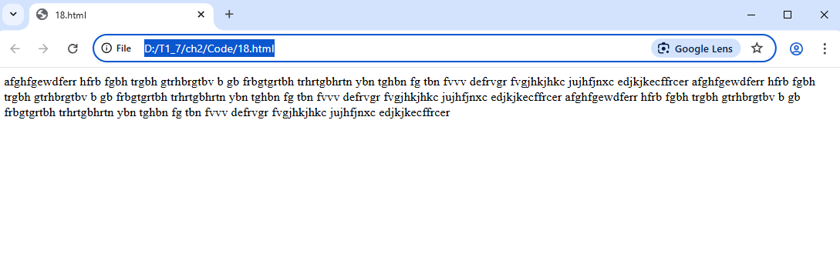

19.html

<html>

    <body>

        <pre>

            afghfgewdferr hfrb fgbh trgbh gtrhbrgtbv b gb frbgtgrtbh trhrtgbhrtnybn tghbn fg tbfvvv defrvgr fvgjhkjhkc jujhfjnxc edjkjkecffrcer

            afghfgewdferr hfrb fgbh trgbh gtrhbrgtbv b gb frbgtgrtbh trhrtgbhrtnybn tghbn fg tbn

            fvvv defrvgr fvgjhkjhkc jujhfjnxc edjkjkecffrcer afghfgewdferr hfrb

            fgbh trgbh gtrhbrgtbv b gb frbgtgrtbh trhrtgbhrtn

 ybn tghbn fg tbn

            fvvv defrvgr fvgjhkjhkc jujhfjnxc edjkjkecffrcer

        </pre>

    </body>

</html>

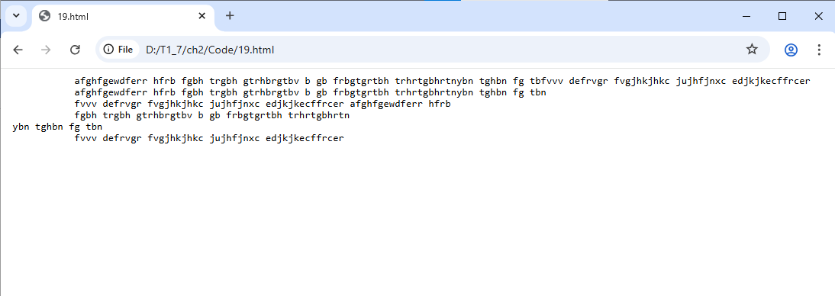

**Link <a> (anchor tag) (hyper link)**

Attributes

* Href specifies the url
* Target two values
* Self (open document in same tab)
* Blank (open document in new tab)
* <html>
* <body>
* new tab <a href="https://www.google.com" target="_blank"> google</a>
* same tab <a href="https://www.google.com"> google</a>
* </body>
* </html>

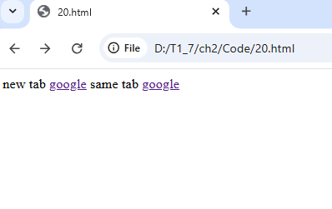

img

src : specifies the path to the img

alt : alternative text

height

width

<html>

    <body>

        <center>

            <img src="a.jpeg" alt="not found"

                height="100" width="100">

        </center>

    </body>

</html>

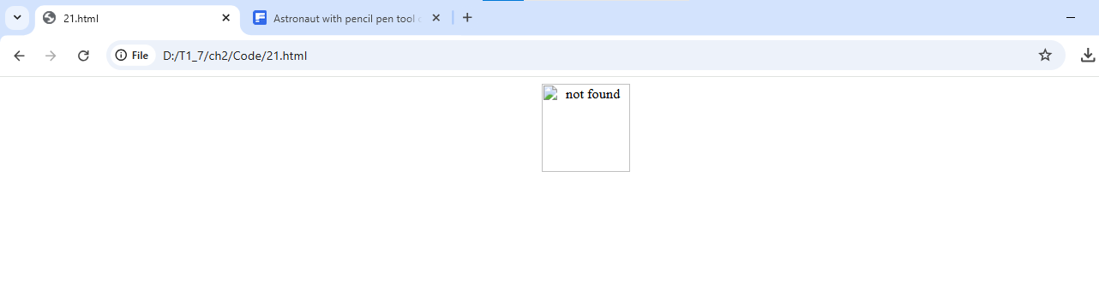

**List**

1. Unordered list <ul>

<li> - list

Type = “disc/square/circle/none”

ByDefult = (small black circle)

<html>

    <body>

        <ul>

            <li>

                abc

            </li>

            <li>

                xyz

            </li>

            <li>

                pqr

            </li>

        </ul>

        <ul type="square">

            <li>apple</li>

            <li> orange </li>

        </ul>

        <ul type="disc">

            <li>apple</li>

            <li> orange </li>

        </ul>

        <ul type="circle">

            <li>apple</li>

            <li> orange </li>

        </ul>

        <ul type="none">

            <li>apple</li>

            <li> orange </li>

        </ul>

    </body>

</html>

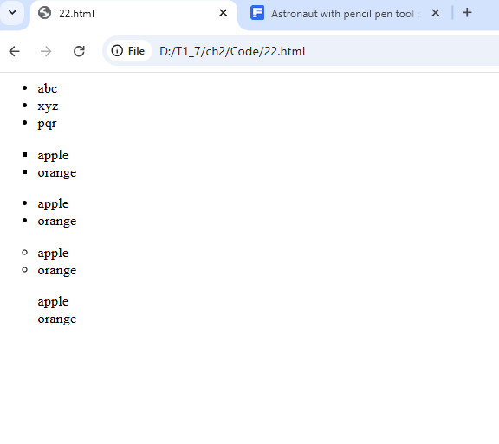

1. Ordered list <ol> <li>

Attributes

Type = “1/ i / I / a / A”

Start = starting values

Reversed = list order should be reversed (9,8,7,6,5 list wise)

By default – number

<html>

    <body>

        <ol>

            <li> abc </li>

            <li> xyz </li>

        </ol>

        <ol type="A">

            <li> abc </li>

            <li> xyz </li>

        </ol>

        <ol type="a">

            <li> abc </li>

            <li> xyz </li>

        </ol>

        <ol type="1">

            <li> abc </li>

            <li> xyz </li>

        </ol>

        <ol type="I">

            <li> abc </li>

            <li> xyz </li>

        </ol>

        <ol type="i">

            <li> abc </li>

            <li> xyz </li>

        </ol>

        <ol start="50" reversed>

            <li> apple </li>

            <li> orange </li>

        </ol>

    </body>

</html>

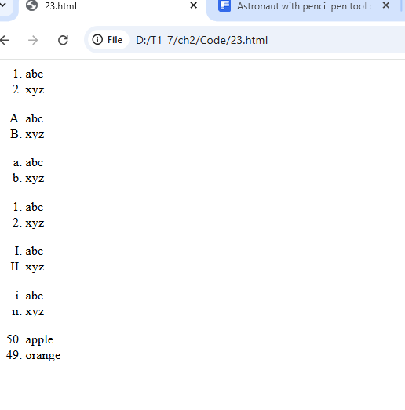

Media tags

1. <figure> & <figurecaption>
2. <audio>

* Controls: show play / push & volume UI
* Autoplay: tries to st audio atomaticaly
* Muted: starts muted
* Loop: plays continously
* <source>: src path type = “audio/mp3”

1. <video>

* Width
* Hight
* <source>: src path type = “vidio/mp4”
* <ifram>
* .pdf
* .html
* Link
* Yt video

Google map

Html tables imp for 5 marks

* Tages
* <Caption> it define a table caption
* <table> defines tabel 
* <th> table header cell
* <Tr> table row
* <td> table data
* <thead> group the headers content in table
* <tbody> group the body content in table
* <tfoot> group the footer concent in table
* Attributes
* Align : “right/left/center/justify”
* Bgcolour : “rgb(x,x,x)
* “#hexacode”
* “colour name ”
* Border = pixels (note “0 = no boder ”)
* Cellpadding = pixels & % => spece btween cell boder & there contents
* Cellspecing = pixels & % => space b/w the cells
* Rules = “ none/ group/ row/cols/all”
* Width = pixels & % => width of the tables